Storage
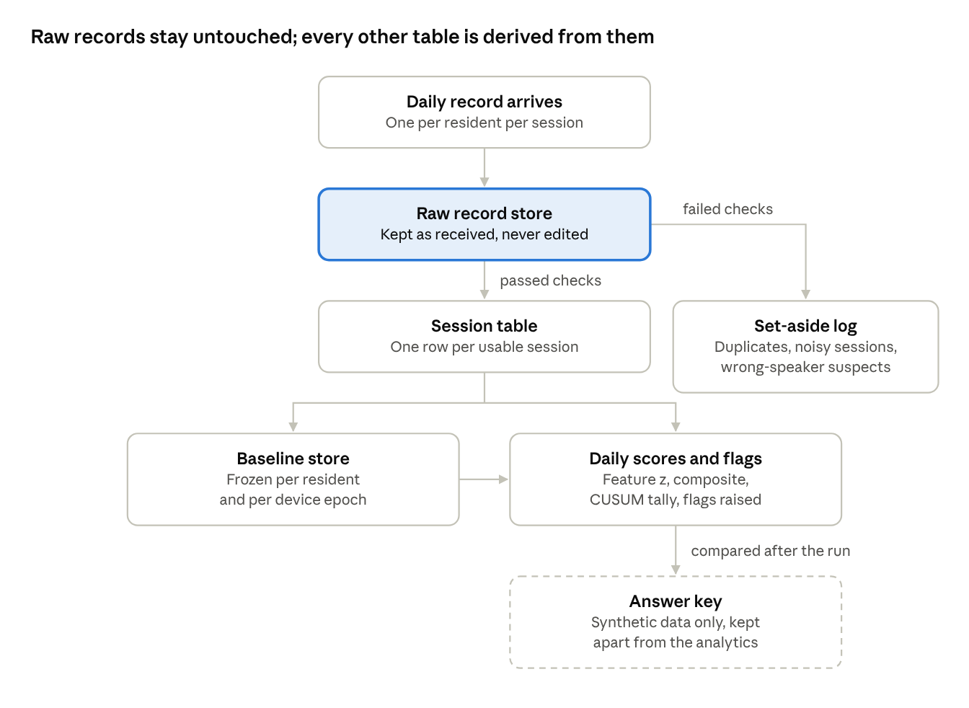
storage flow · 7 stores, raw store highlighted
Only the raw store receives data from Team 1. Every other table can be rebuilt from it, and the answer key never touches the analytics.

Processing
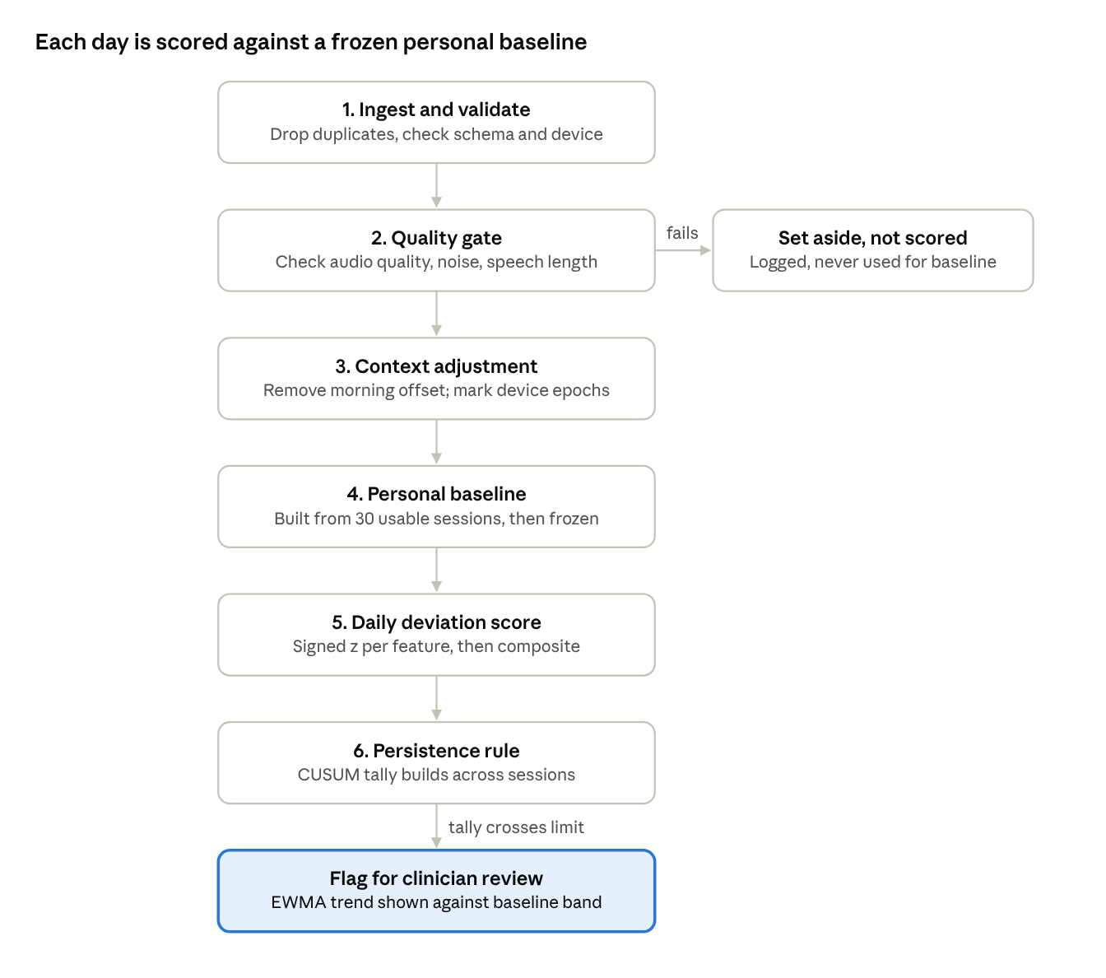
daily processing · 6 stages to a flag
A single odd day never raises a flag. Only a deviation that persists across several sessions does.

